CHANTAL bOTHA
5/5/2016

Secondary Housing

fLAMING SILVER TRADING 19 PTY LTD

1” Affordable Housing

1.5” Competitors

2” Why Flaming Silver

3” Costs And Revenue

Flaming Silver Trading 19 PTY LTD

Business Report Notebook
IN THIS SECTION:
- Affordable Housing
House prices in South Africa are declining again, after a gradual price rise in 2014.
The house price index for medium-sized houses rose by 3.9% y-o-y to November 2015, according to ABSA. However when adjusted for inflation, the average house price actually fell by 0.8% - a slowdown from the 9.2% (3.2% in real terms) y-o-y price increase during the same period last year.
Small-sized houses rose least, their prices up only 1.8% (-2.8% in real terms) y-o-y to November 2015. Large-sized houses, on the other hand, rose by 8.3% (3.4% in real terms) y-o-y.
In November 2015:
- the average price of small homes (80-140 sq. m.) was ZAR 877,000 (US$ 52,293)
- the average price of medium-sized homes (141-220 sq. m) was ZAR 1,241,000 (US$ 73,997)
- the average price of large homes (221-400 sq. m) was ZAR 1,989,000 (US$ 118,599)
"Nominal house price growth of 5%-6% is forecast for 2016, with the risk to the downside against the background of economic and consumer sector trends and prospects...real house price growth is expected to remain under severe pressure in the next 12-18 months," says ABSA.
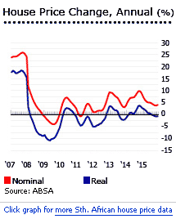

Flaming Silver Trading 19 PTY LTD

Competitor 1
- http://vibraneat.co.za/product/vibracrete-housing/
R48, 000.00
- 3×6 selling at R48000 Installed or R2850 sq/m.
- Insulated concrete.
- Offices, Wendy huts, braai rooms, informal housing, garden sheds, tool sheds, stables, kennels, construction site offices, security rooms, guard houses, garages, low cost housing.
- Comes in a kit form quick and easy to install for R500 per metre 2.1m high walling.
- Manufacture and installed to your specifications.
- Can be disassembled.
- Installed in 2-3 days.
- Any sizes you require available.
Top of Form
Bottom of Form
Top of Form
Bottom of Form
Category: Vibracrete Housing.
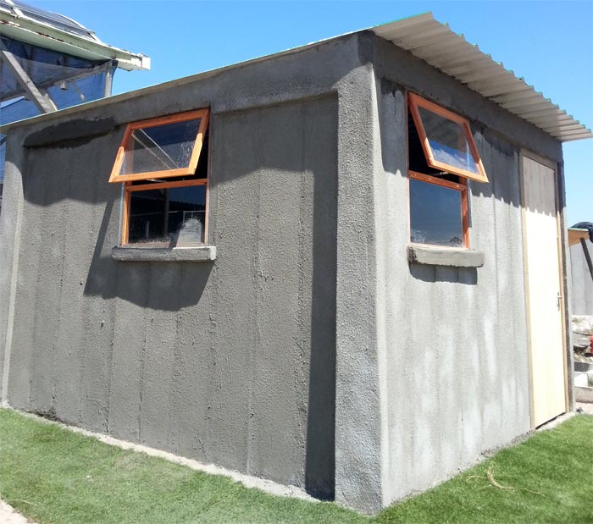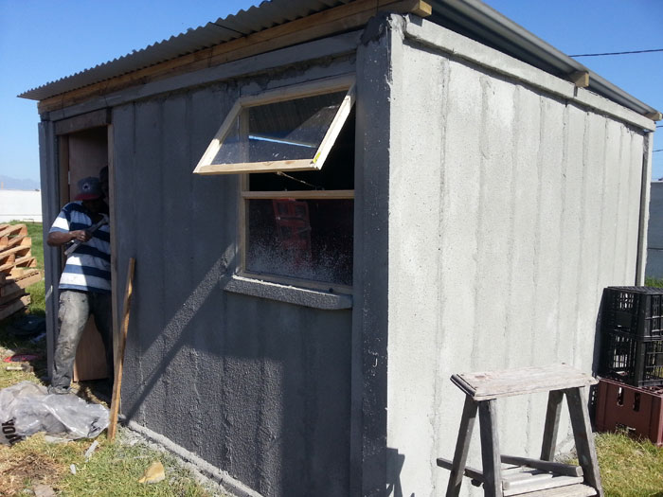

Flaming Silver Trading 19 PTY LTD

Competitor 2
IN THIS SECTION:
- http://www.junkmail.co.za/services/building-and-renovation-services/western-cape/cape-town/stellenbosch/vibracrete-houses-on-terms/37386987
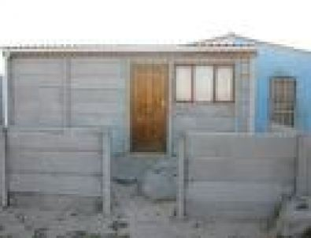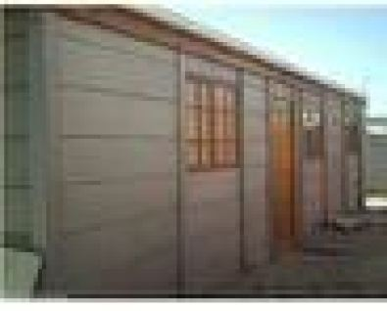

Flaming Silver Trading 19 PTY LTD

Competitor 3
IN THIS SECTION:
- http://imvusaonline.co.za/?page_id=444
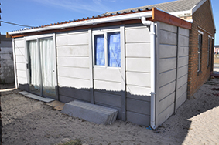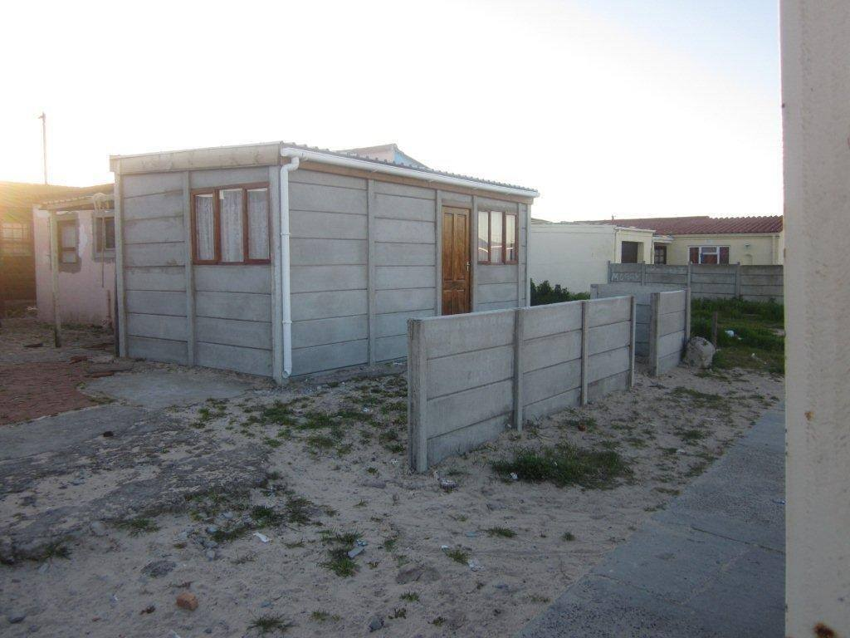

Flaming Silver Trading 19 PTY LTD

Why Flaming Silver
IN THIS SECTION:
Flaming silver took a look at what is currently being offered.
Yes there is a handful of companies providing this service but not to its full potential.
We saw a need. This need is young people and middle aged people looking to buy a new house but the system and economy makes it hard as less and less people are being approved for bonds.
So as a result they get married and put up a Wendy house.
We here to offer an easy and affordable vibracrete structure that looks like a brick home both inside and outside but much less and affordable.
With previous vibracrete structures we were able to set up a complete home with the following:
- A fully tiled house
- Kitchen Counter
- Plastered both inside and outside
- Fully Painted
- Running Water

All extra requirements will be charged extra

Flaming Silver Trading 19 PTY LTD

Job Creation

We have found that in our communities that young guys who left school at an early age are stuck without work. These young guys have the skills to assist with building theses structures but there are no jobs out there and big companies fail to give them the opportunity because of a lack of experience.

Flaming Silver is willing to provide jobs to our communities. There will always be jobs available for the vibracrete structure. Based on our research and the affordability of this project, there will always be work.
We will provide a standard rate of R150 per day. Bases on a monthly figure, each worker will be paid R4000pm.
This will be enough to sustain the worker and their family.
As it stands 21,5% of our youth are unemployed. We are aware that we as a company will not dramatically change this rate.
But if we can at least help one person, then we have done a great deal.

QUICK FACT
Of the 67 135 people who are economically active (employed or unemployed but looking for work), 15,2% are unemployed.
Of the 34 184 economically active youth (aged 15 – 34 ) in the area, 21,5% are unemployed

Flaming Silver Trading 19 PTY LTD

Cost Involved

The costs involved for this vibracrete structure varies from case to case because each house will be different.
The bigger the house the more the costs will be. Extras on the house such as tiles, geysers, kitchen cupboards and counters will be an extra charge.
On the previous project we spent R100, 000 on a 52 square meter house.
This included the following:
- 1 big bedroom
- 1 big bathroom with shower
- 1 big lounge
- Open plan kitchen
- Fully tiled
- Kitchen counter top
- Plastered walls
- Fully painted house

We will have customized packages to suit our client’s pockets. This way we provide excellent service to our customers.

See Examples Below

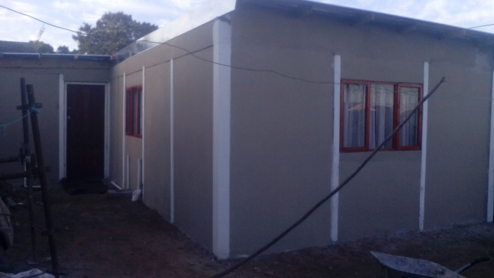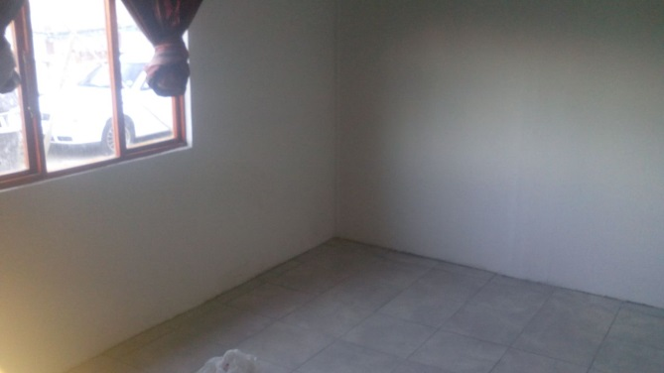

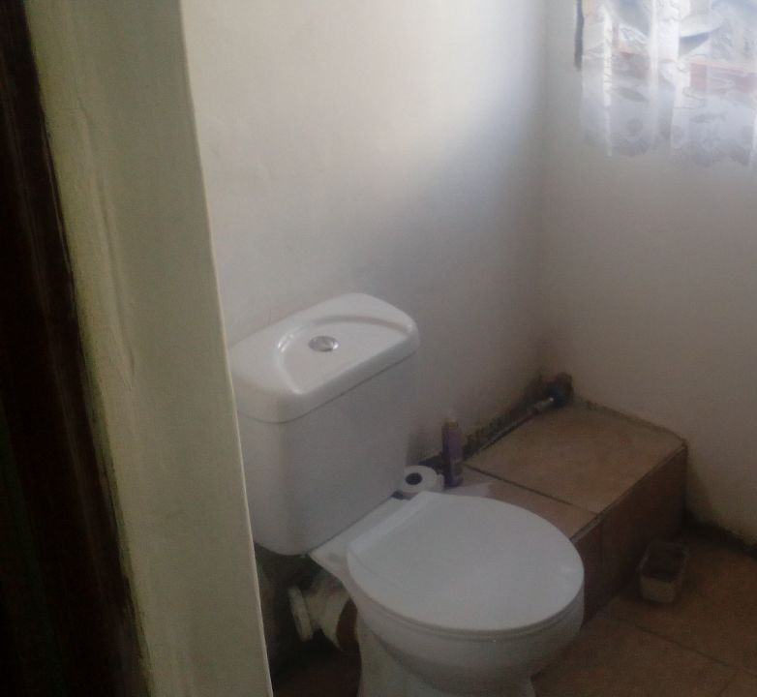

The markets were surprised by the rate hike
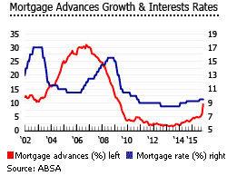
In a surprising move, the South African Reserve Bank´s (SARB) Monetary Policy Committee (MPC) raised the repo rate by 25 basis points to 6.25% during its last meeting on November 19, 2015. The MPC had been expected to maintain the repo rate at 6%.
The bank noted “the key risks are a marked depreciation of the rand; worsening drought conditions and their likely impact on food prices; and the possibility of additional electricity tariff adjustments.”
Prime and variable mortgage rates were at 9.5% in October 2015, up slightly from 9.25% in October 2014.
The repo rate was raised twice in 2015, first in July (from 5.75% to 6%) and then in November (from 6% to 6.25%), mainly due to increased inflationary pressures and expected further pressure on the rand.
Inflation was around 4.8% in 2015, down from 6.1% in 2014, and 5.8% in 2013, according to the IMF. In December 2015, annual inflation rose to 5.2% from 4.8% in the previous month, according to Statistics South Africa (Statistics SA).

Household finances are weak
In 2015, South Africa´s households were under some financial strain, because of slower economic growth, low employment levels, interest rate hikes caused by inflation, as well as weaker consumption.
"The level of household savings remains extremely low, while the debt-to-income ratio stays around the 78% level and credit-active consumers’ risk profiles deteriorating somewhat further up to mid-year. These factors caused growth in household credit balances to stay in the low single digits up to the third quarter," says ABSA.
"The value of outstanding household mortgage balances is forecast to continue to record low single-digit growth over the next 12 months, affected by expected trends in interest rates, the state of household finances and consumer confidence," according to ABSA.
Outstanding mortgages rose by 6% by value in October 2015 from the same period last year, to around ZAR 1.22 trillion (US$ 74 billion), according to the South African Reserve Bank (SARB). Of which, 70.6% were household mortgages.

Recalling the boom years
During South Africa´s housing boom (from 2000 to 2006), national house prices rose by an average of 20% annually. House price rises peaked in October 2004 with 35.7% annual growth (32.5% in real terms).
However in Q1 2008 the boom ground to a halt, following the global financial crisis.
- In 2008, house prices fell by 0.5% (-9% in real terms)
- In 2009, house prices rose 0.3% (-5.4% in real terms)
- In 2010, house prices rose 2.3% (-1% in real terms), encouraged by South Africa hosting the 19th FIFA World Cup
- In 2011, house prices rose by just 1% (-5. 1% in real terms), due to lower economic growth, rising inflation, and political corruption concerns
- In 2012, the housing market bounced back. House prices rose by 9.2% (3.3% in real terms)
- In 2013, house prices rose by 3.6% (-1.6% in real terms)
- In 2014, house prices rose by 8% (2.6% in real terms)

The 2000 to 2006 boom was driven by 4 main factors:
- The emergence of a financially stable black middle class had a tremendous impact on housing demand, encouraged by individual tax reliefs, in the context of a growing economy.
- South Africans who had parked money offshore during the Apartheid era were allowed (and required) to bring it back by September 2004. Much of this money went into property.
- Better stability and security helped. During Apartheid and its sequel, property prices had badly lagged the economy, as the security situation went from bad to worse.
- Lastly, the Financial Sector Charter in 2003 boosted mortgage loan growth. Financial institutions committed to provide ZAR 42 billion (US$5.45 million) of housing finance to the low income market. Then in 2006, the CGT exemption on primary residences was raised from ZAR1 million (US$127,129) to ZAR1.5 million (US$190,694). Transfer duties on properties were lowered too. For example, no transfer duty is payable on properties valued at ZAR500,000 (US$63,565) or less.

The subsequent slowdown of house prices in 2008 can be attributed to the full implementation of the National Credit Act in mid-2007, interest rate hikes, and to the global financial crisis.
The National Credit Act aimed to protect borrowers from over-indebtedness, by limiting the amount of funds that can be borrowed, and requiring every lender to assess borrowers’ credit-worthiness. It requires lenders to disclose every term in the contract and gives the borrowers the right to request their credit report, and to challenge the report if there are inaccuracies.
The act has tended to reduce the supply of mortgage loans.

More residential construction activity
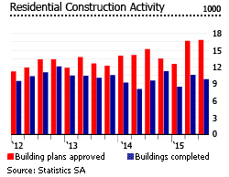
Residential building approvals rose by 6.26% during the first three quarters of 2015, according to Statistics South Africa. Approvals of flats and townhouses rose most (up by 9.08%), and small houses measuring less than 80 sq. m. (up by 8.92%).
Residential completions increased by 7.64% to 28,865 units in the first nine months of 2015. In terms of total area, completions were up by 13%.

Bleak economic outlook in 2016
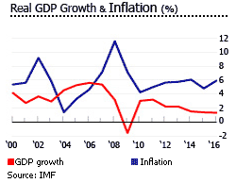
South Africa barely escaped technical recession after posting 0.7% q-o-q growth in Q3 2015, following a contraction of 1.3% q-o-q the previous quarter, according to Statistics South Africa. On an annual basis, the country´s real GDP rose by 1% in Q3 2015.
The current pace of growth will not be enough to reduce unemployment. In the third quarter of 2015, South Africa´s unemployment rate stood at 25.5%, or around 5.4 million, according to Statistics SA. From 2000 to 2014 average unemployment was persistently high, at 24.8%.
To cut the high jobless rate to 14% by 2020, real GDP would need to grow an annual average of 5.4%, according to the government’s National Development Plan. However, this is unlikely to happen. In 2016, South Africa´s economy is expected to expand by only 1.5%, followed by 2.1% growth in 2017, according to South African Reserve Bank´s (SARB) deputy governor Daniel Mminele. ‘‘Growth continues to be constrained by certain cyclical elements, such as weaker global trade and commodity price declines, as well as more idiosyncratic factors,’‘ says Mminele in a speech.
The South African economy grew by just 1.4% in 2015, after expanding by 1.5% in 2014, 2.2% in both 2013 and 2012, 3.2% in 2011, and 3% in 2010, according to the IMF.
In December 2015, Fitch Ratings downgraded South Africa´s credit rating to BBB-, just above junk status. Fitch also changed their outlook from stable to negative due to lower than expected economic growth. Standard and Poor´s (S&P) also lowered South Africa´s outlook from stable to negative.
South Africa is Africa’s biggest economy, with an estimated population of 54.9 million and a GDP per capita of US$ 5,784 in 2015. It has formidable manufacturing and financial sectors. It is the world’s largest exporter of gold and platinum. Tourism is also a key source of foreign exchange.

President Zuma´s dwindling popularity
ANC leader Jacob Zuma became president of South Africa in 2009, despite corruption charges. Zuma is an economic leftist who supports wealth redistribution, but has assured foreign investors that their interests will be protected. Zuma is a polygamist who has married 6 times and is reported to have 20 children, including one "love-child".
He has pledged to create 5 million jobs by 2020, but that target looks increasingly unrealistic.
Critics claim that Zuma is indecisive, appeases factions within the party, while safeguarding his own position. Yet African National Congress support seems only to fall slightly, and in the recent elections the ANC vote (65.9%) crushed the liberal Democratic Alliance (16.66%) and the newly-formed radical leftist Economic Freedom Fighters (6.35%).
Populist measures are not out of the question. Zuma told a ruling-party rally in the northern town of Polokwane in January 2014 that foreigners might face restrictions on buying landed property, and be limited to leasing land. Foreigners can now own immovable property without restriction.
Land redistribution is an ongoing issue. Farmland is still mostly white-owned. Officials have signalled that large-scale expropriation is on the cards, with the government aiming to transfer 30% of farmland to black South Africans.
The president recently got a public approval of 36%, down from 64% in 2011. President Zuma has faced more than 700 corruption, tax-evasion, money-laundering, and fraud charges (which were eventually dropped), among others.
In December 2015 he fired the well-respected Finance Minister Nhlanhla Nene, replacing him with an unknown backbencher, David van Rooyen. The reasons were obvious: Nene had opposed extravagant state spending, including on state-owned South African Airways (whose chairwoman Dudu Myeni is President Zuma´s close friend). Nene had also barred an acquisition of a new presidential jet, and advised that South Africa could not afford a trillion-rand Russian nuclear deal.
Nene´s firing undermined investor confidence. Middle-class South Africans flooded the streets of Johannesburg, Pretoria and Cape Town on December 16, 2015 as part of the #ZumaMustFall campaign. President Zuma revised his decision a few days later, appointing Gavin Gordhan as finance minister. Investors calmed after Gordhan´s appointment, since he had already served in the same position from 2009 to 2014.
Although President Zuma remains powerful within the ANC, his deteriorating popularity is likely to cost ANC losses in the upcoming 2016 municipal elections.
Former Health Minister and ANC veteran Barbara Hogan has publicly criticized President Zuma, stating that Nene´s dismissal "crossed a line". “We do not have the power to recall the President. Only the ANC has the power to recall. This man is creating economic sabotage,” said Hogan.
Currently, President Zuma is promoting his ex-wife Nkosazana Dlamini-Zuma, African Union´s chairwoman, as his successor. Dlamini-Zuma´s main competitor to succeed the presidency is Cyril Ramaphosa, a former union leader.
Although political analysts predict ANC to experience a drop of below 50% support in major cities, the party is also expected to remain in power. “The ANC is not about to lose power, and Jacob Zuma is aware of that fact, which is why he acts with such brazenness,” according to Prince Mashele of the Pretoria-based Center for Politics and Research.

